LOGIN PAGE

## 1.My sql workbench :creation of

## 

## 2.getUser:insertion of single user

## 

## 

## 3. Get All Users:

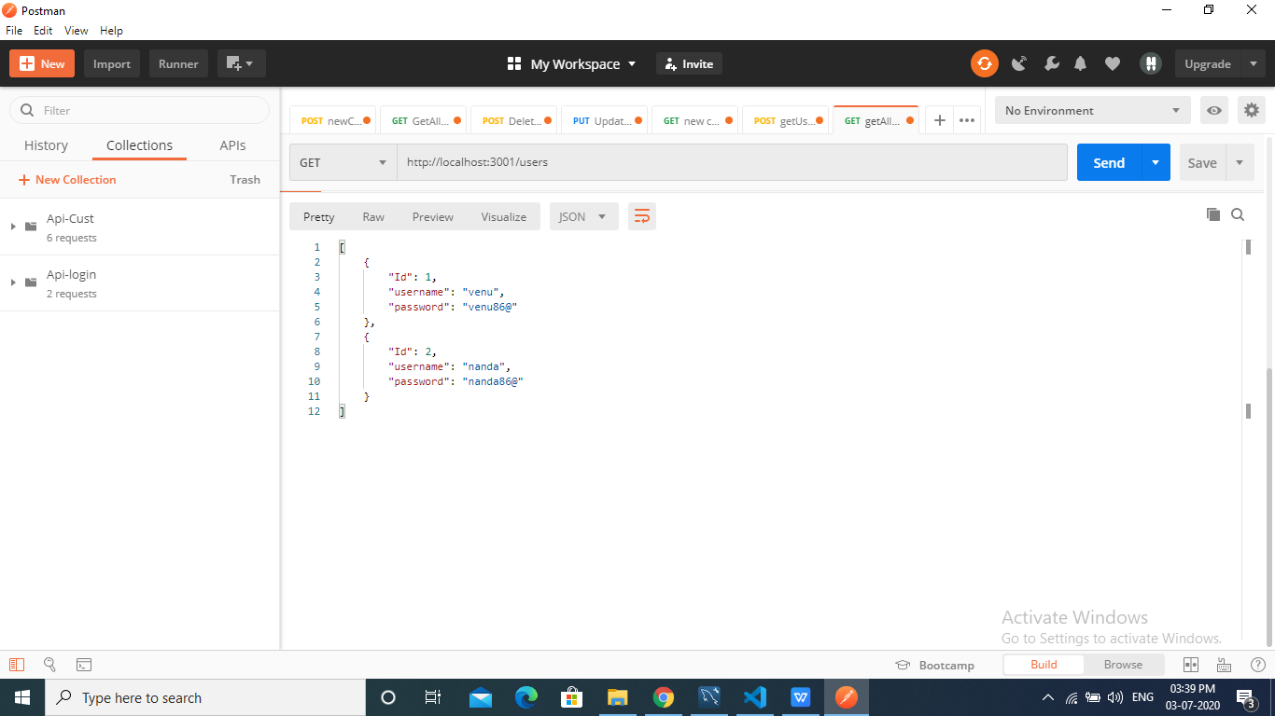

## 4.GetUserById

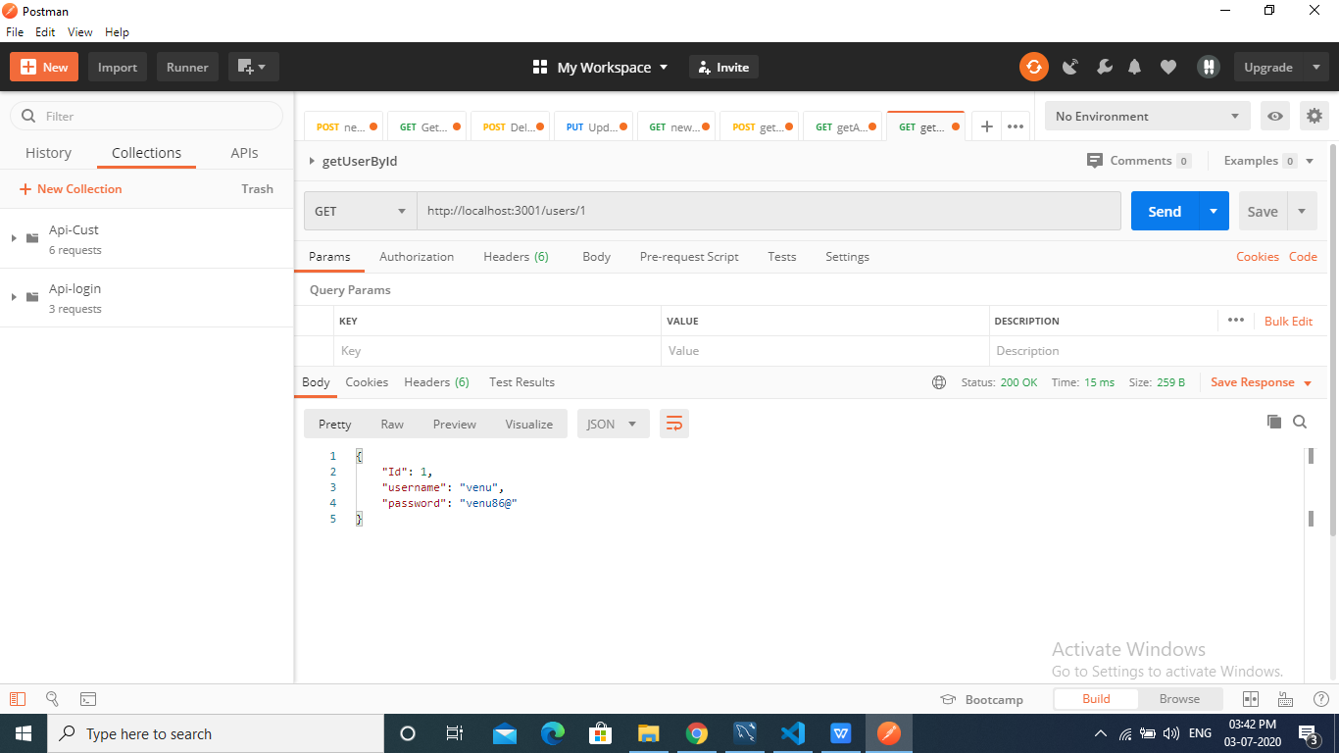

## 5.GetDeleteSingleUser

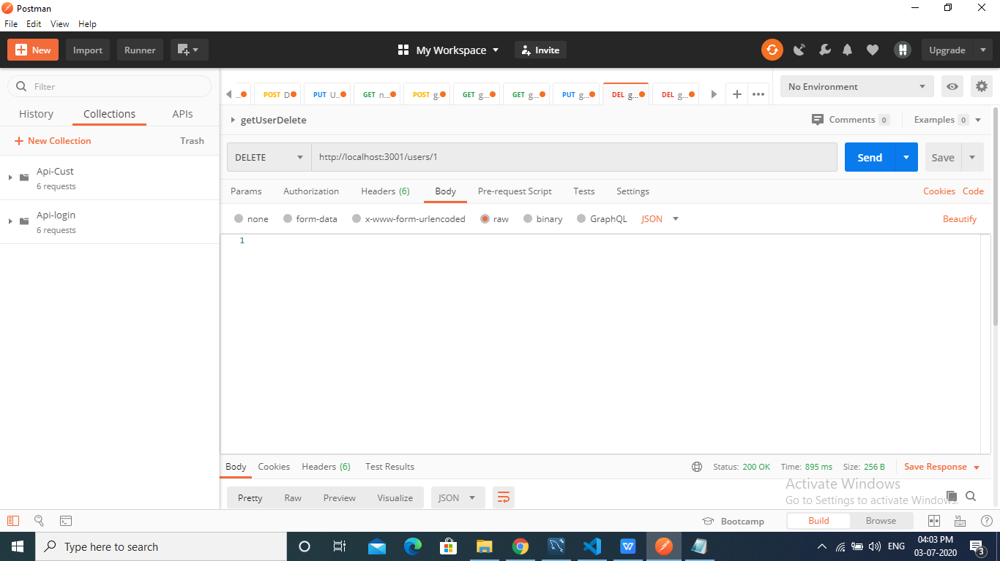

## 6.AfterDeletingSingleUser

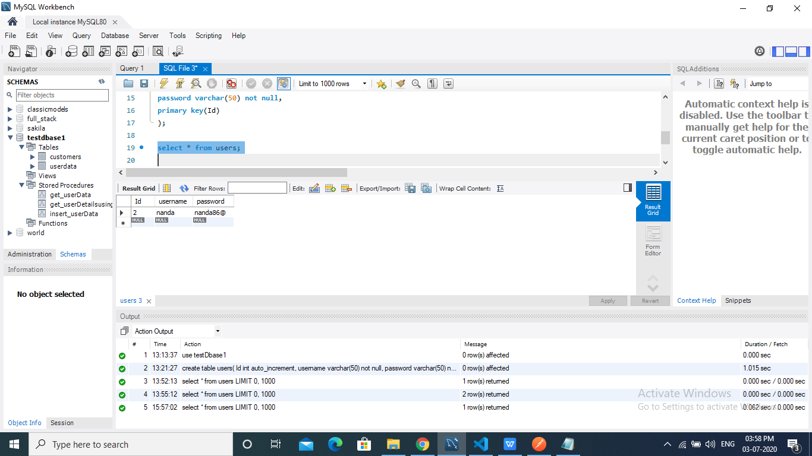

## 7.GetDeleteAllUser

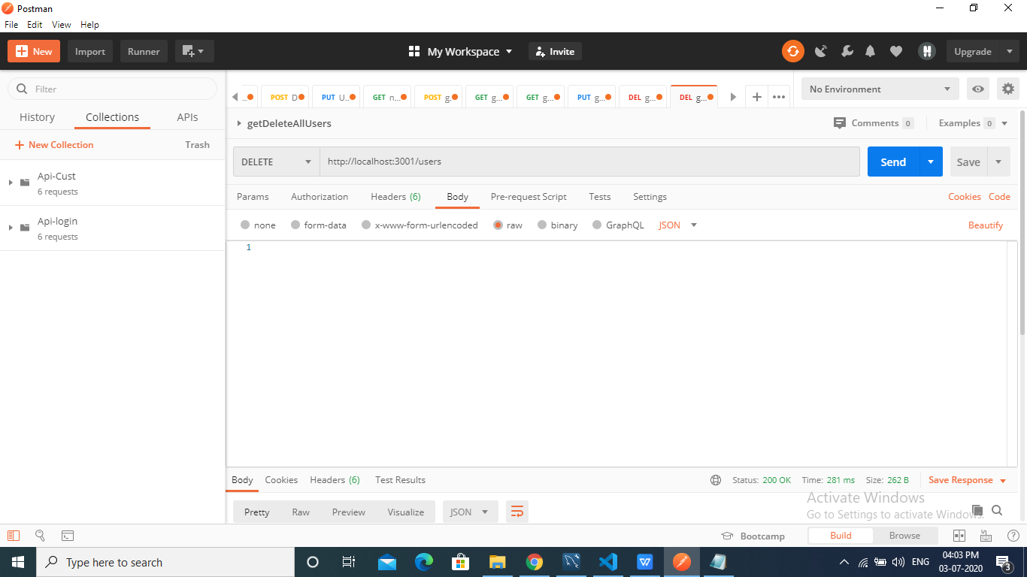

## 8.AfterDeletionAllUsers

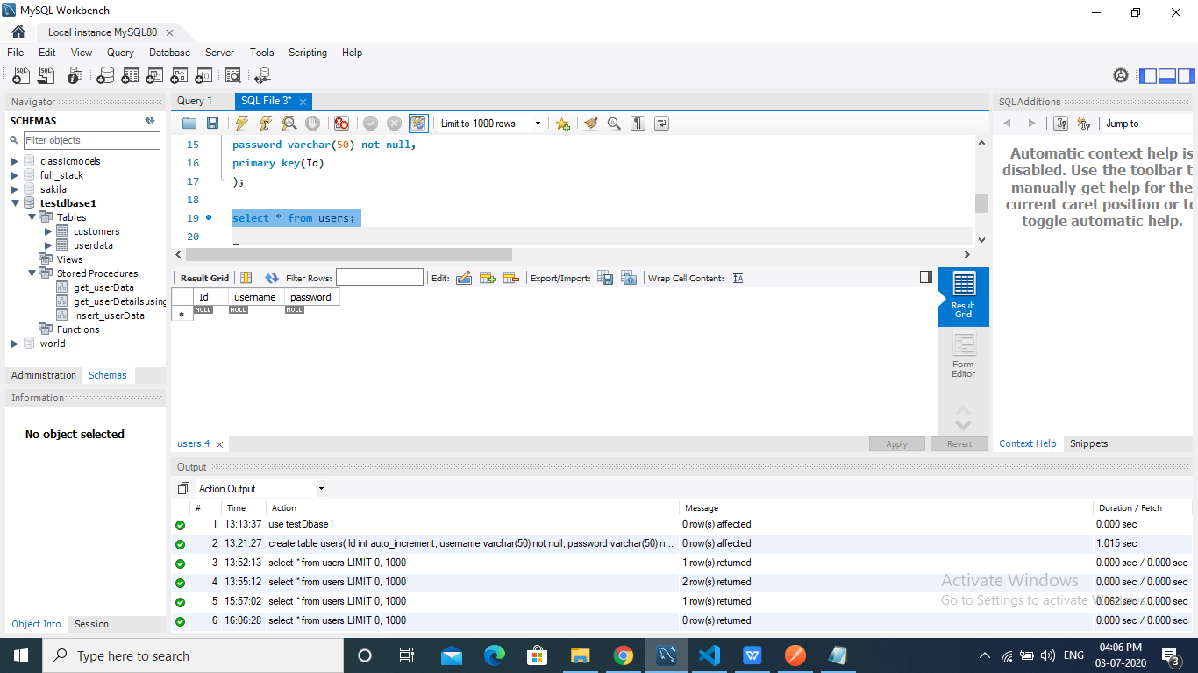

## 

REGISTRATION FORM

## 1.Creation of table in my sql workbench:

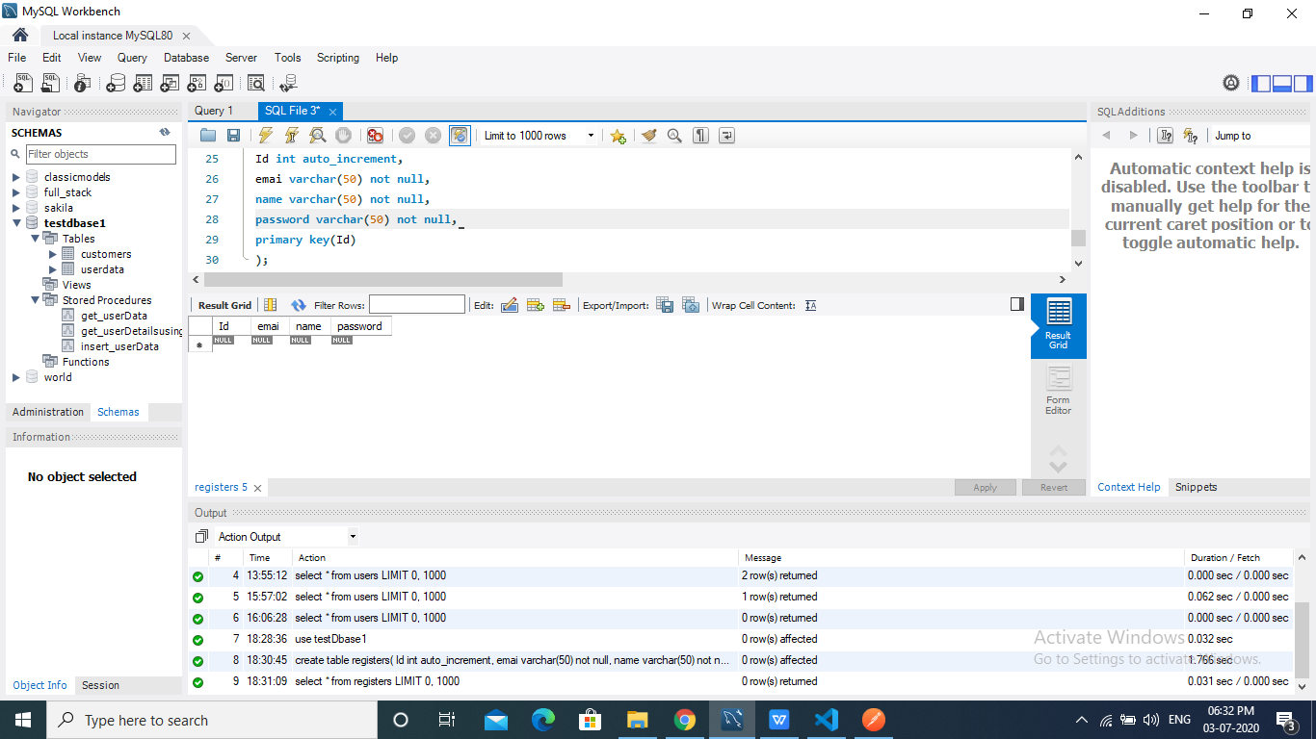

## 2.GetRegisterInsert

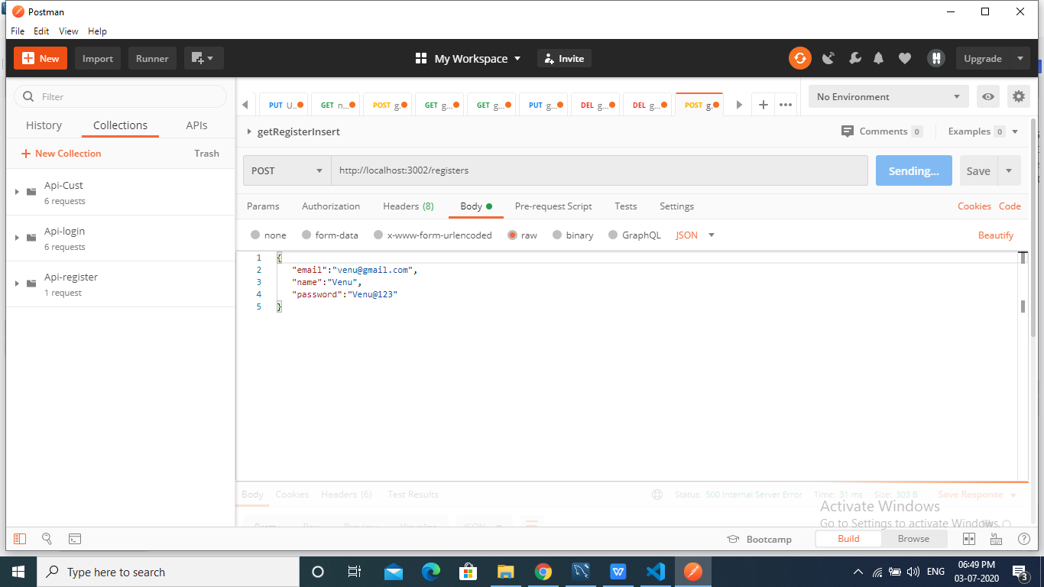

## 3.GetAllRegisters

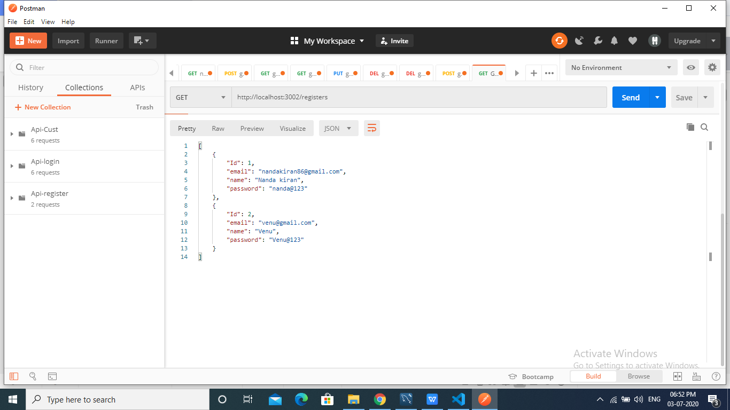

## 4.Get User By Id:

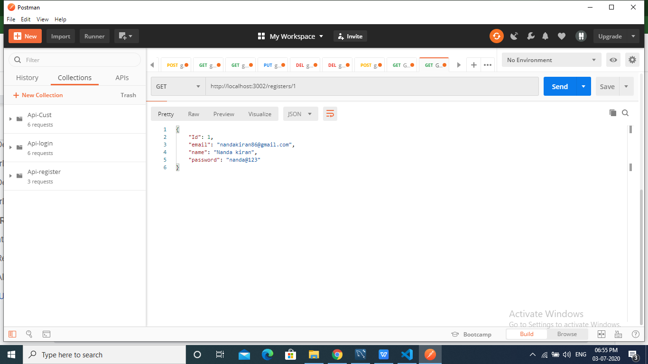

## 5. Update Register Email:

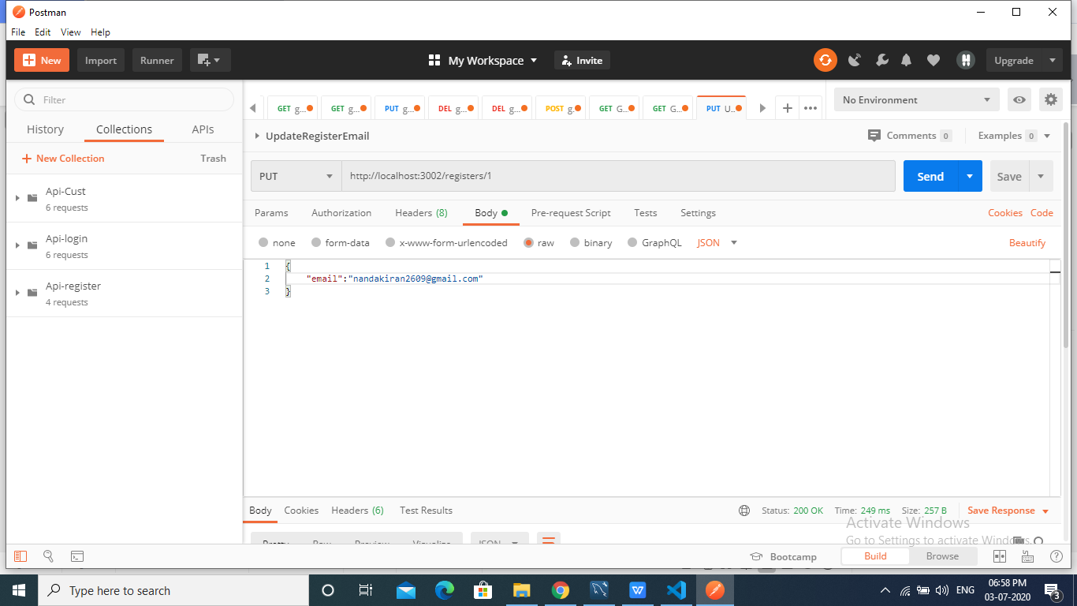

## 6. Delete Single Register:

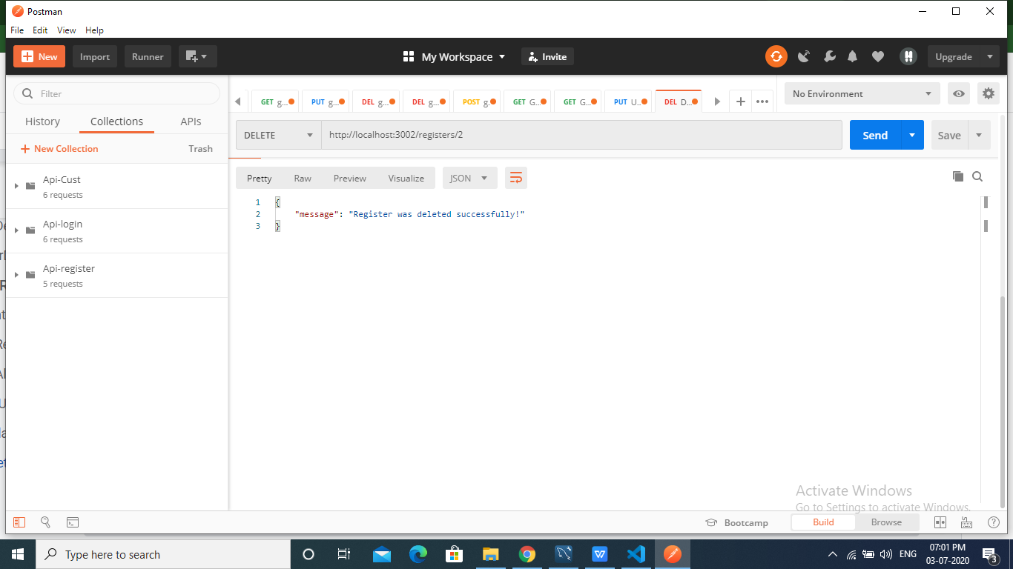

## 7. Delete All Registers:

## 

## 8.After Deleting all The Registers MySQL Table

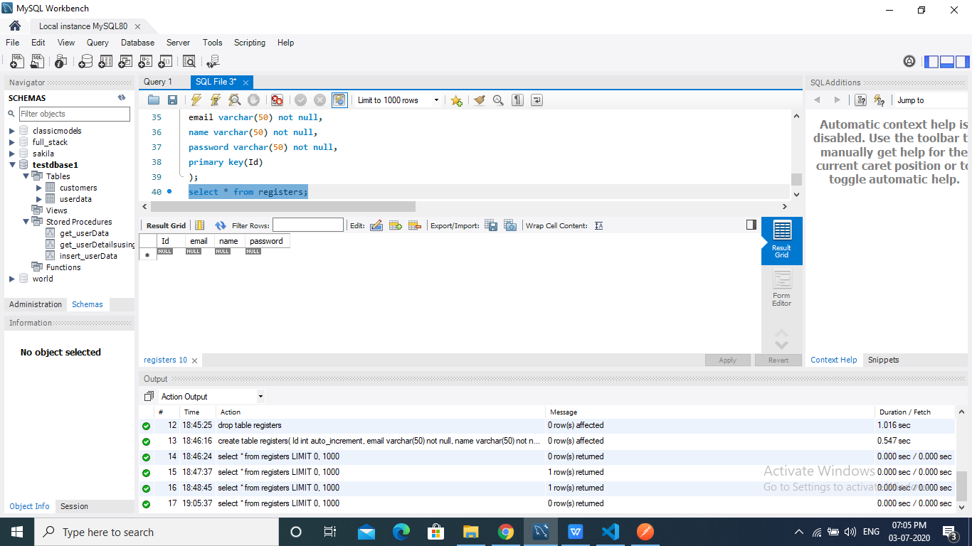

FEEDBACK FORM

## 1.Creation of table in mysql

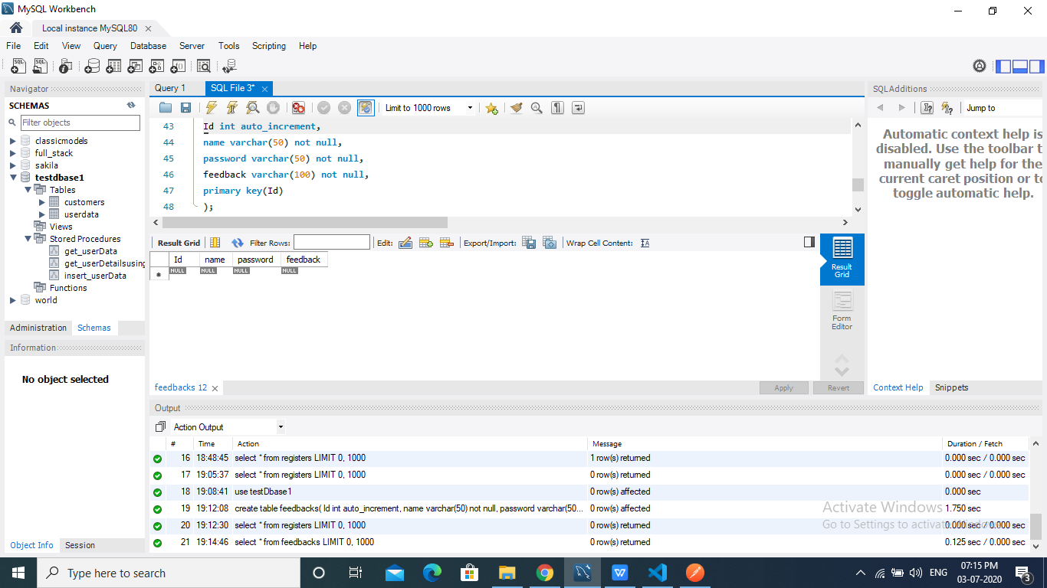

## 2.Feedback Insertion

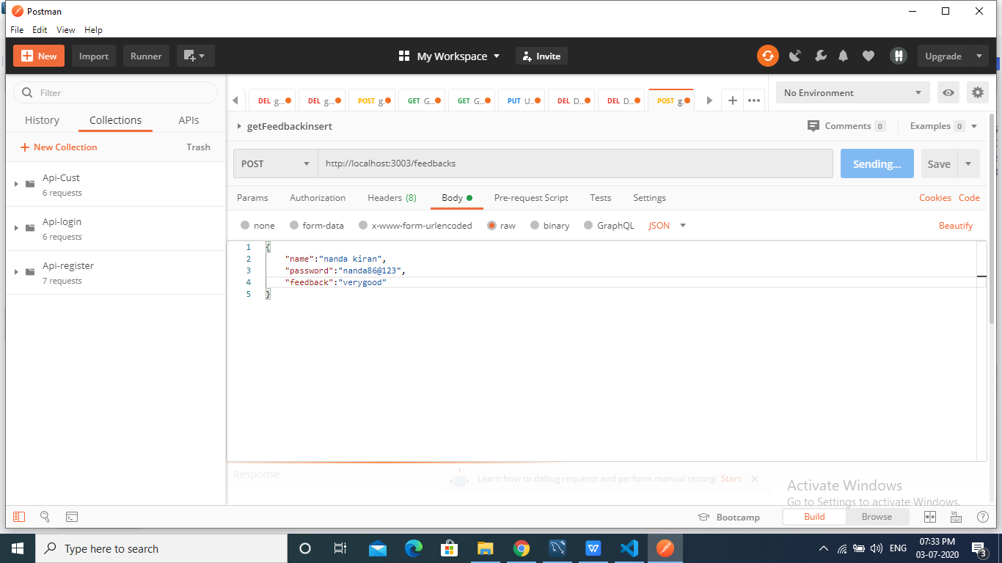

# 3. Get All Feedback Inserts:

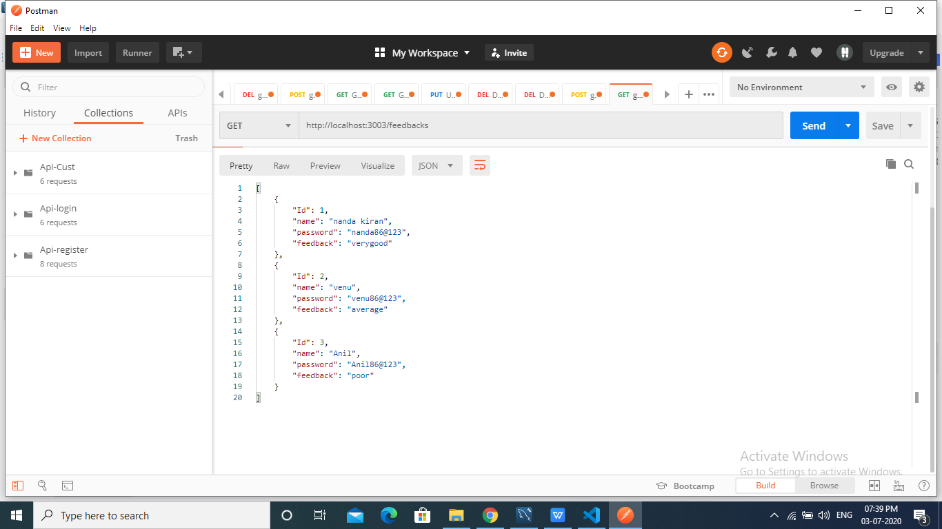

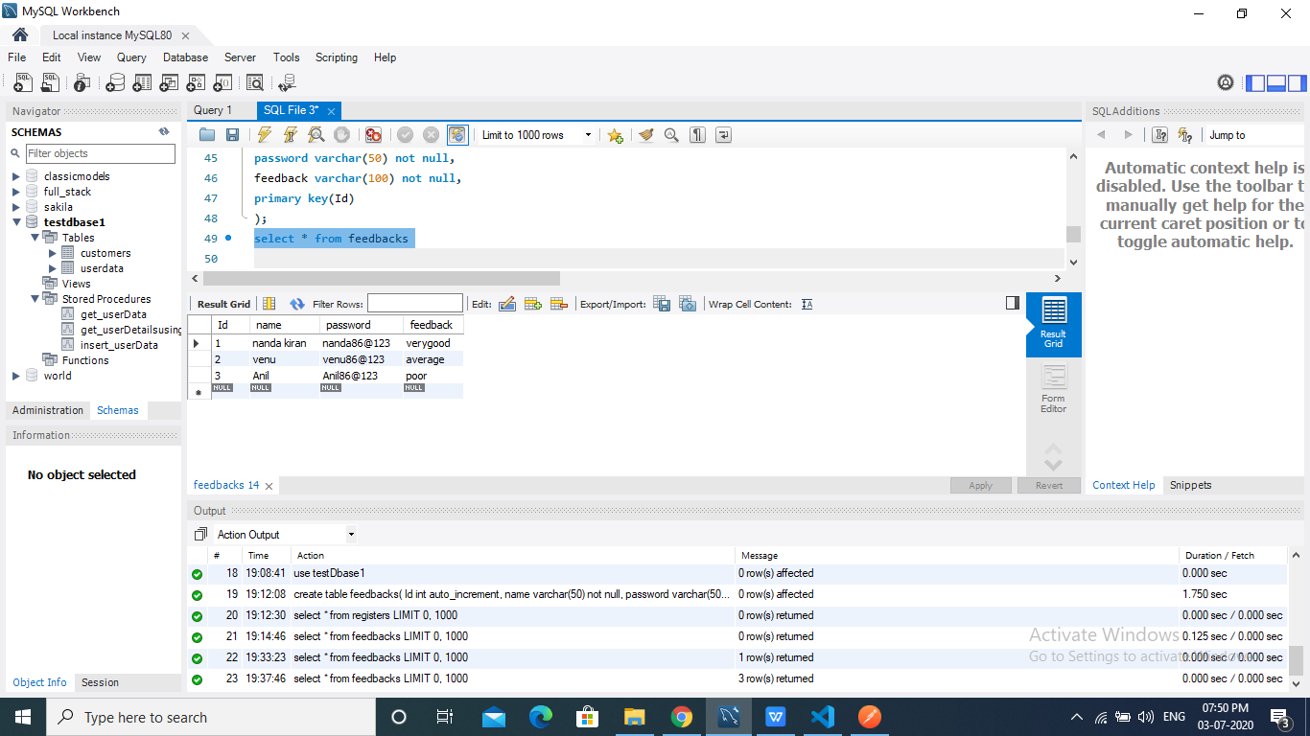

## 4.Get FeedBack By Id

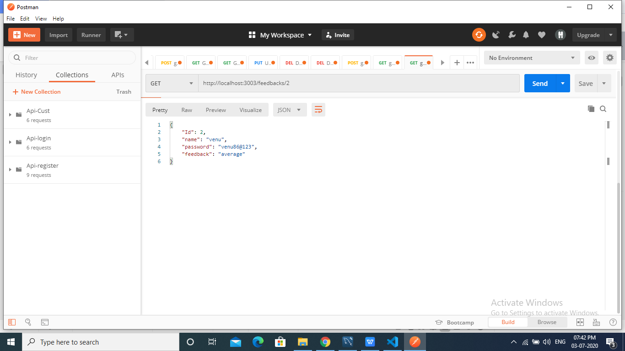

## 5.Update Password For Feedback/2:

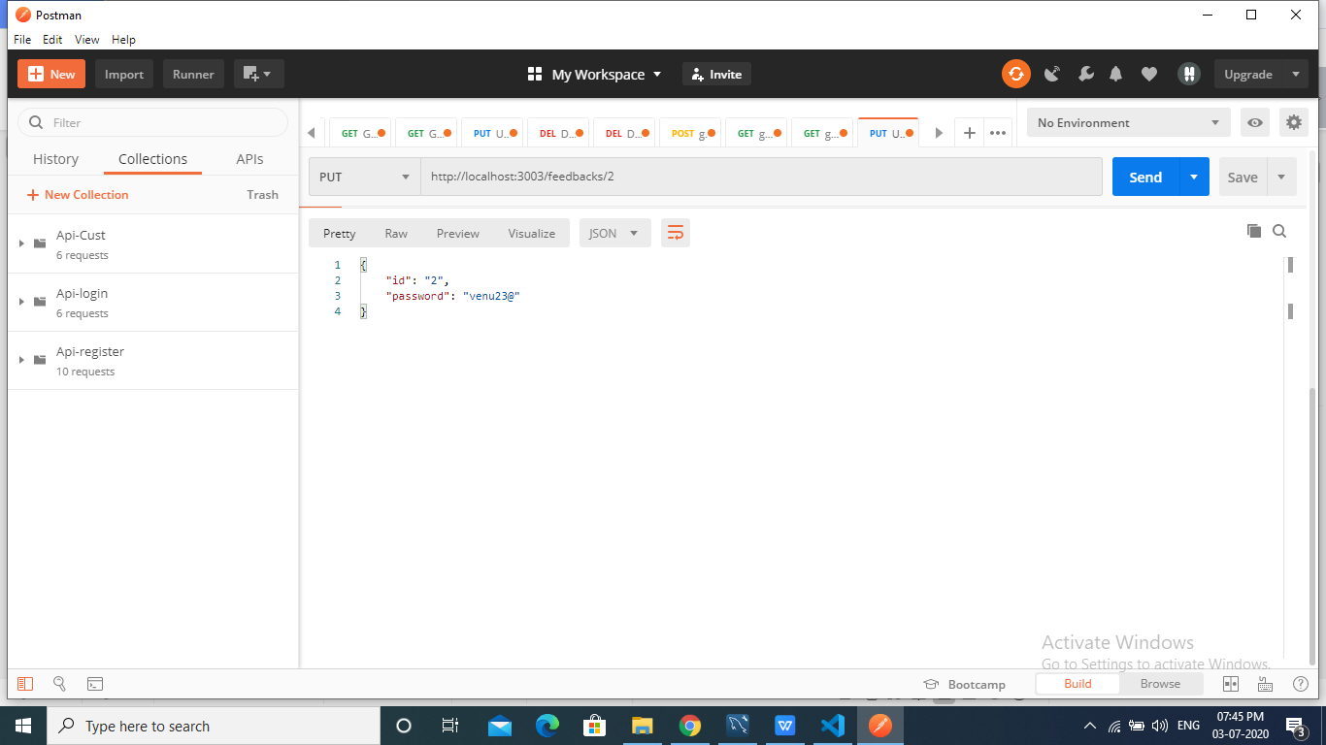

## 6.Delete Single Feedback

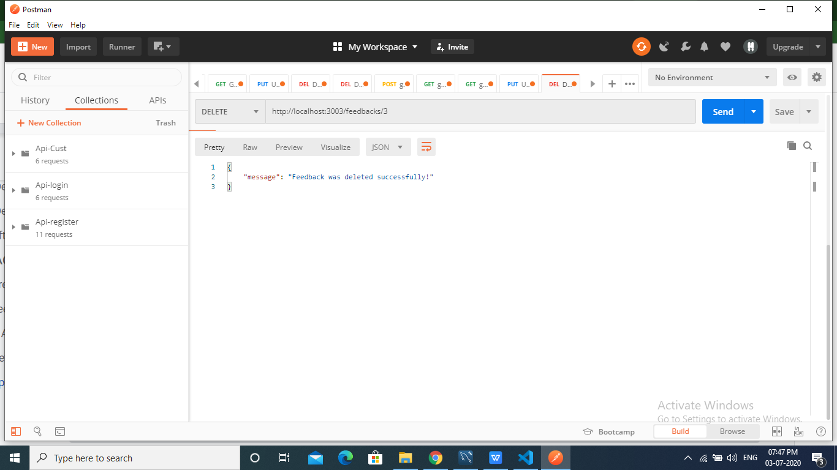

## 7.Delete All Feedbacks:

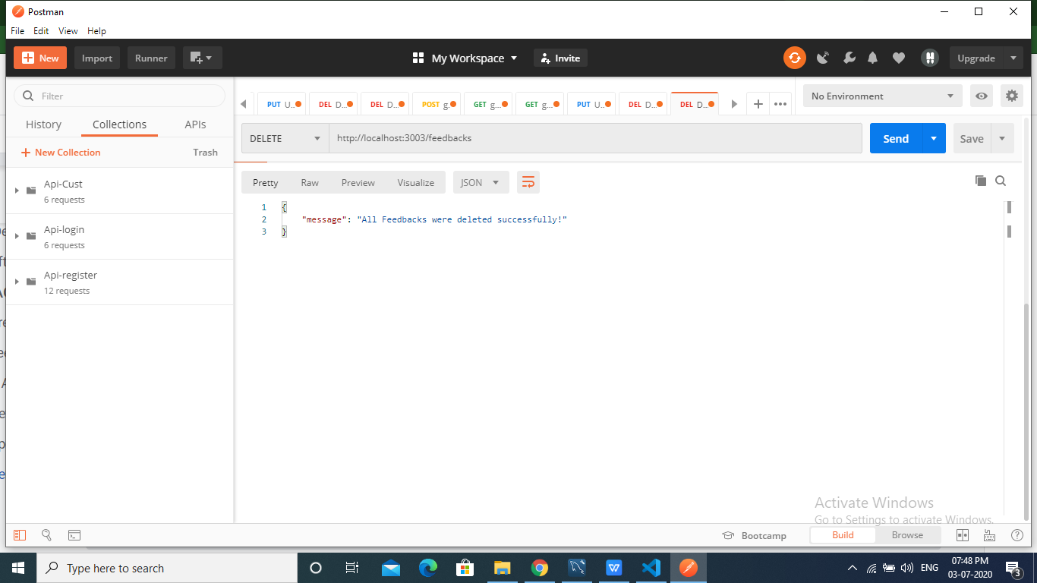

## 8.After Deletion Of All Feedbacks:



 

 

 

 

 